Commiting changes
cd "C:\Users\hml91\Desktop\Claude\Projects\Website"
git add -A # -A means "All" — stage every changed, new, or deleted file
git commit -m "Add new publications" # takes a snapshot of what's staged
git push # sends the snapshot to GitHub, which triggers the site rebuild

Controlling Navigation Bar and Pages
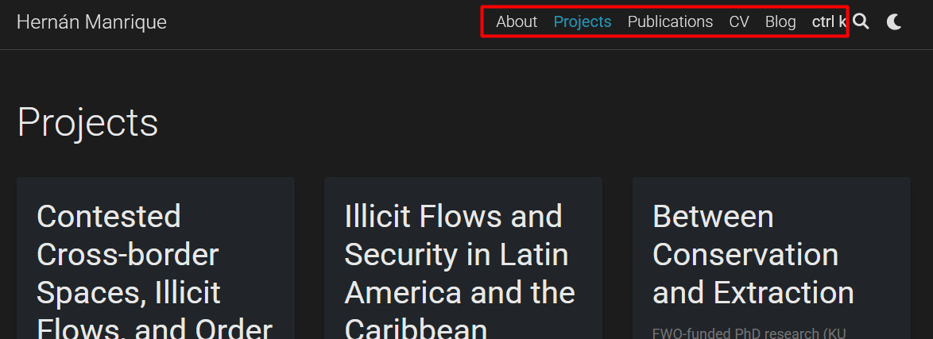

/_pages… and check whether nav: true

